#11915010 Raghu Punnamraju

#11915043 Anmol More

#11915001 Sriganesh Balamurugan

#11915052 Kapil Bindal

**Chatbot URL -** [**https://bot.dialogflow.com/7ece3edf-bff2-4527-ae49-c68209b471ee**](https://bot.dialogflow.com/7ece3edf-bff2-4527-ae49-c68209b471ee)

**Telegram Bot username – @AAIAssignmentCorona_Bot**

Table of Contents

I. Data Collection 2

Methodology 2

Sources Used 2

NLP Pipeline 2

**Codebase explanation** 2

Pre-processed Dataset description 3

Clean Knowledge Base 4

II. Version 1: Build a simple similarity-based FAQ bot 4

Command line model 4

**Question similarity approach** 4

**Steps to run** 4

Flask Deployable model 5

Bi directional similarity approach 5

III. Version 2: Build a Dialogflow based FAQ bot 7

Knowledge based corpus 7

Intent Action and Parameters 7

Realtime webhook 8

Web Based Bot 10

Telegram Bot 12

IV. Discussion and Ways to Improve 13

Personas 13

Ideal Conversation Flowchart 14

Ways to improve your bot 14

Improve user experience 14

Improve bot knowledge base 14

Multiple model deployment 15

Realtime Integration 15

References 15

# Data Collection

## **Methodology**

We focused on the following data collection principles – reliability, simplicity, contemporariness and automation & collected 400+ FAQs from International and government of India websites.

* **Reliability:** It is absolutely critical that the data is reliable and at no cost we can be the reason to spread false information. We limited our data sources for statistics to world meters and WHO. For health ad clinical information, we limited the data sources like WebMD, who, etc.
* **Simplicity:** While gathering the FAQs, we focused on simplicity as it is absolutely critical for the users to understand and relate the responses. Information must be understood and explained in simple English. This enabled us to reduce our processing needs later.
* **Contemporariness:** We made sure no data source is older than one week. As the statistics and care suggestions are changing on a daily basis, we did not want to respond with stale information.
* **Automation:**  We gave automation the less priority as we wanted to focus on the quality and simplicity first. Our automation was limited to the data processing as opposed to data collection. We did the data collection manually.

## **Sources Used**

1. European Centre for Disease Prevention and Control - <https://www.ecdc.europa.eu/en/covid-19/questions-answers>
2. Official Website Belgium - <https://www.info-coronavirus.be/en/faq/>
3. Govt of Karnataka Website - <https://www.mohfw.gov.in/pdf/FAQ.pdf>
4. WHO - <https://www.who.int/news-room/q-a-detail/q-a-coronaviruses>
5. Government of India website - <https://www.mohfw.gov.in/pdf/FAQ.pdf>

## **NLP Pipeline**

As explained in diagrams below, we used two different methodologies to build pipeline as explained below

### **Codebase explanation**

* *FAQ_codebase_1.py* – This contains code to combine multiple data sources collected and then clean and create json format dataset for Bert based model. Additionally a csv set is created to run different models based on similarity score. Sample JSON format output :

* *FAQ_codebase_2.py – This contains code to use BERT based model and return output based on user’s query*

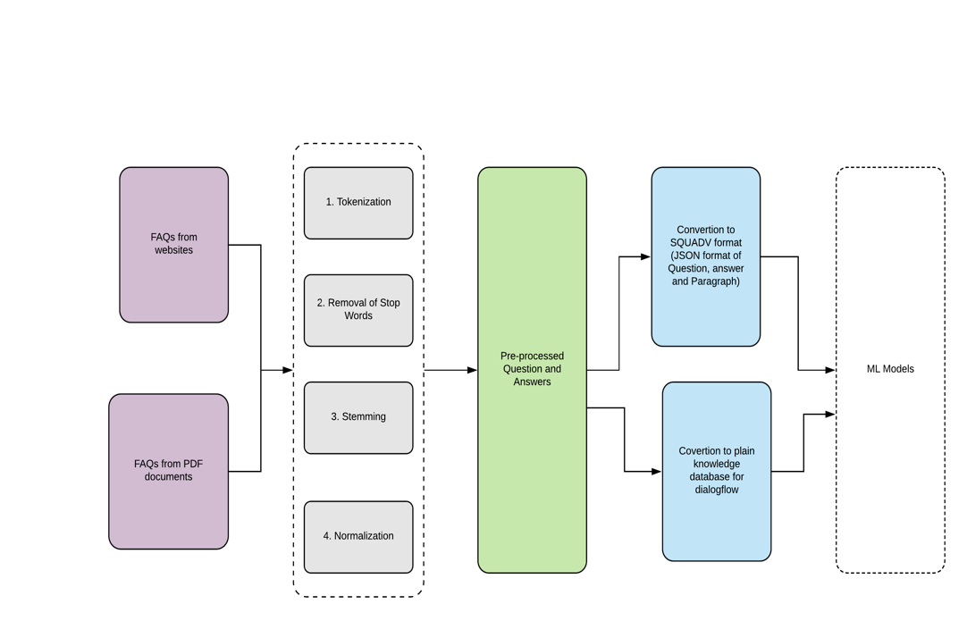

## **Pre-processed Dataset description**

Pre processed dataset is submitted as ‘dataset_collected.csv’ with following fields

* Title – Describes group of queries like ‘General Information’, ‘Info from Government’ etc.
* Question – Question that can be answered from a given paragraph
* Context – Paragraph collected
* Text – Answer to the question
* Source – Website, PDFs, etc
* Source URL – URL of data collection
* Organization – Organization from which data was collected
* Country – If related to specific country, region, otherwise International
* Last Retrieved Time – Time of data collection

## **Clean Knowledge Base**

**This file has been submitted as ‘knowledge_base.csv’**

# Version 1: Build a simple similarity-based FAQ bot

Two different versions of program are built. Both can run on command line, but for smaller size and speed we have provided detailed steps for a simpler model.

## **Command line model**

Though we have tried models, we are delivering similarity based approach as a command line model. As this is fast compared to bert models, which we tried as flask deployable model.

### **Question similarity approach**

At first we create embedding with our own question corpus to find similar questions that have been manually annotated. Next whole question is converted to vector embeddings.

Now, for every query that user asks a vector to vector comparison is done using cosine similarity and most similar question is looked up. The answer to most similar question is sent as reply by bot.

### **Steps to run**

Please use virtual env and install packages from requirements.txt if direct run of python_run.py fails

Please make sure data/knowledge_base.csv and models/*pkl files are present in current directory

>python python_run.py

Detailed steps to build and run (Takes less than 60 seconds)

1. conda create --name aaiassignment
2. conda activate aaiassignment
3. pip **install** -r **requirements**.**txt**
4. python Model_Codebase_1_Question_Similarity_Featurization.py
5. python python_run.py

**Screenshot from two different machines of running code**

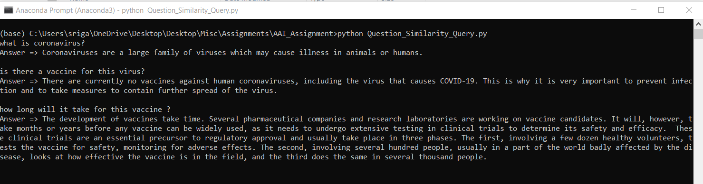

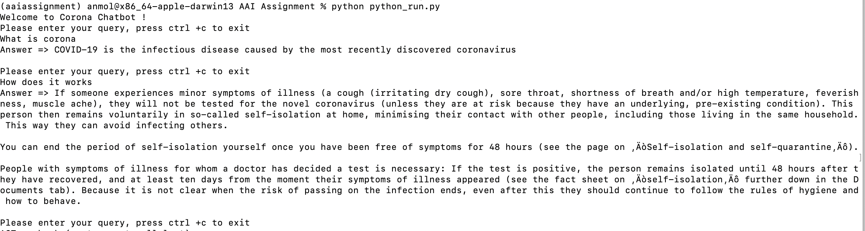

## **Flask Deployable model**

### Bi directional similarity approach

Here we took a pretrained bert model of nlp, and retrained it using out dataset for multiple epochs. The final model is a Question-Paragraph based model, which looks for similarity in question and paragraph and returns the sub content from paragraph as output.

This relies on json format structure for data

**Model** : Due to heavy model size that couldn’t fit even after compression, we are submitting a Onedrive URL (Please request for access if un accessible) – <https://isbhydmoh-my.sharepoint.com/:f:/g/personal/anmol_more_cba2020s_isb_edu/Ei1RNOdbSvxDqK6EZm5Q4QIBrTPJvAfsP8FFbzXQSCbVhw?e=9JsJCV>

**Configuration required** :

* This requires additional configuration with gcloud APIs to connect it to dialogflow and can’t be run directly, hence providing running code output.
* Below folder structure can be used to run a flask server to serve requests on local machine.

**Steps to run** : python api.py

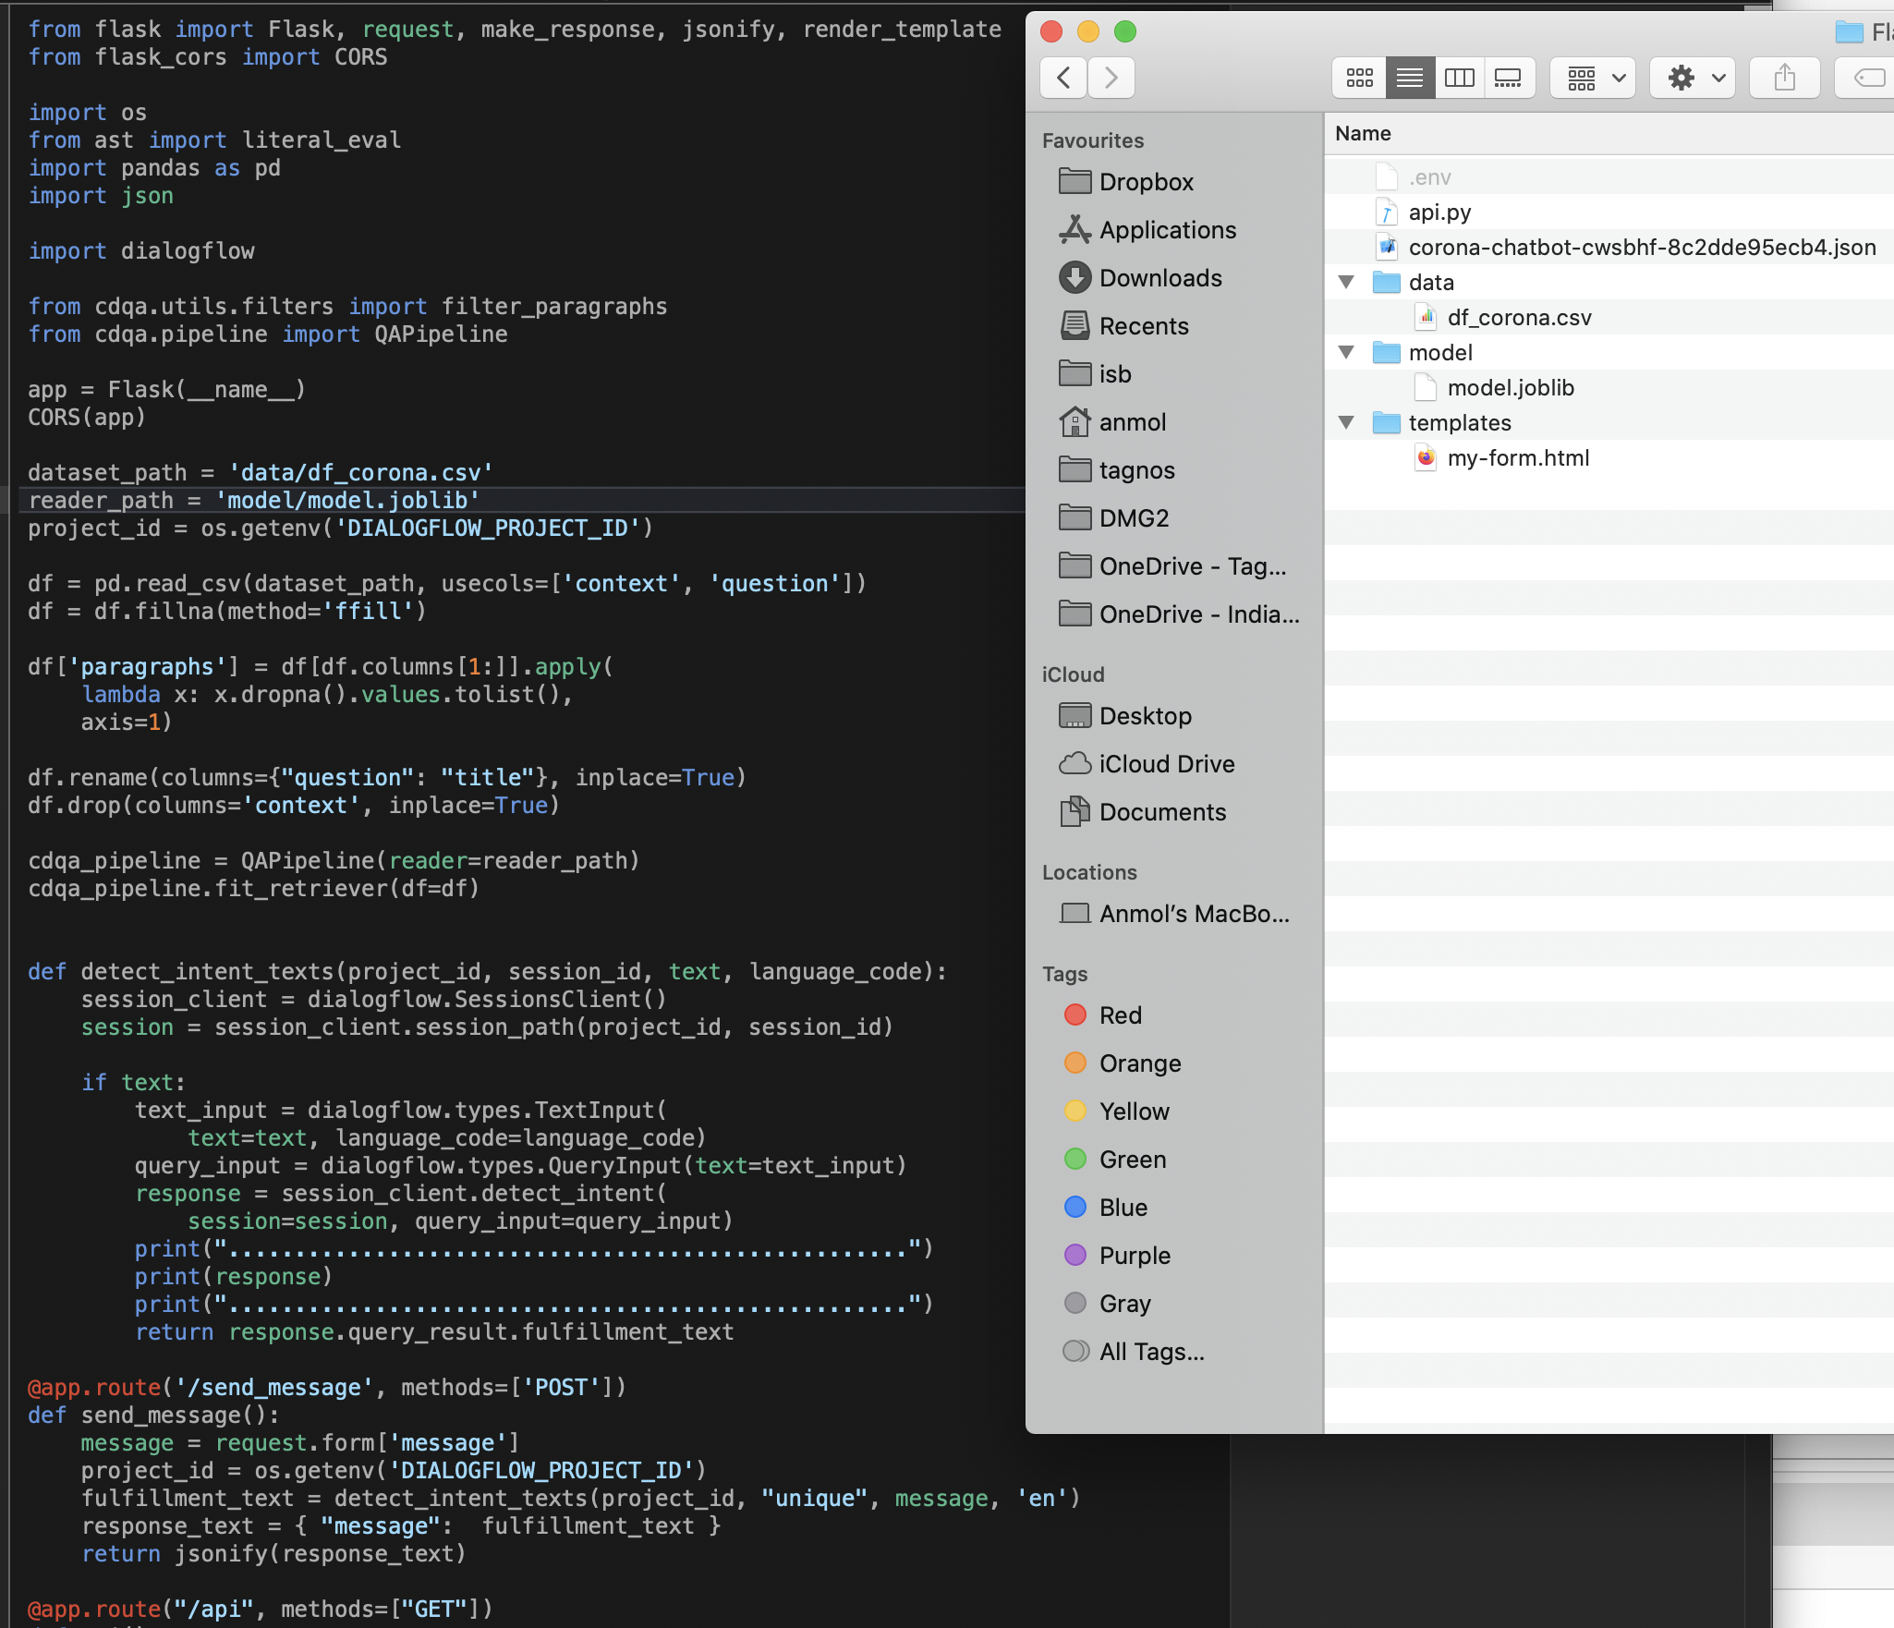

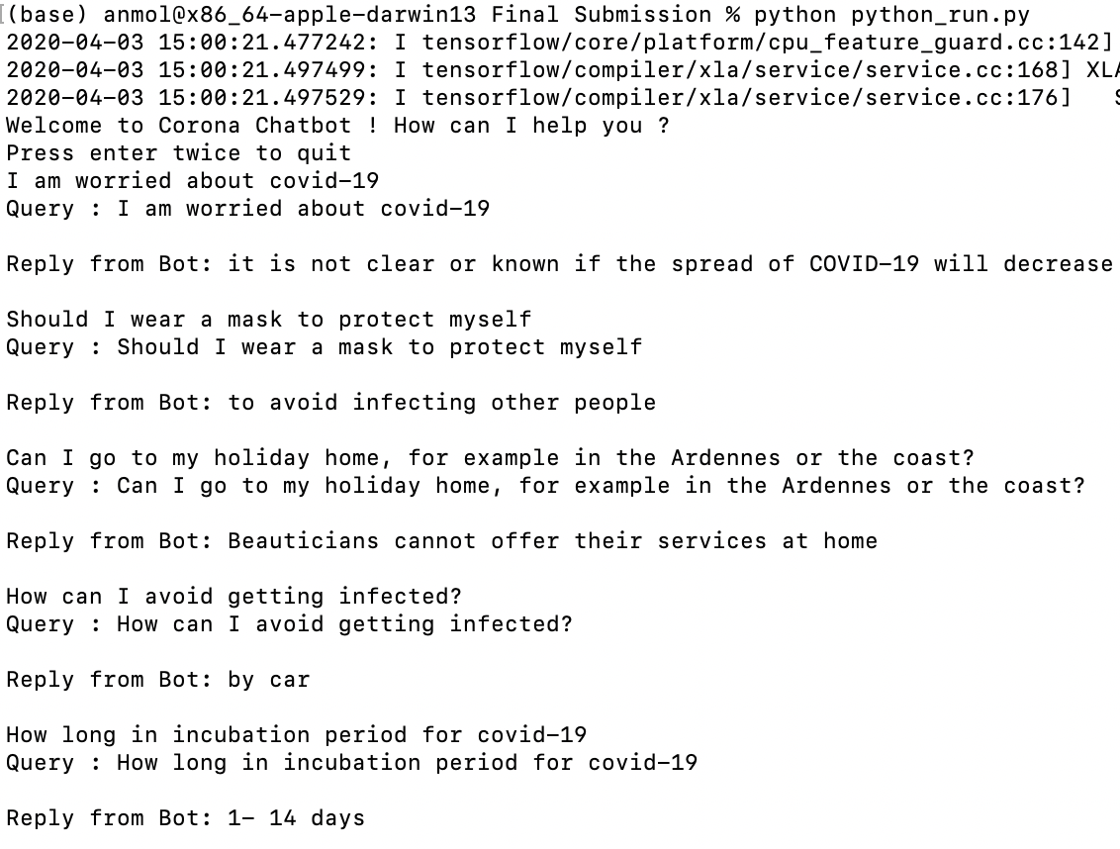

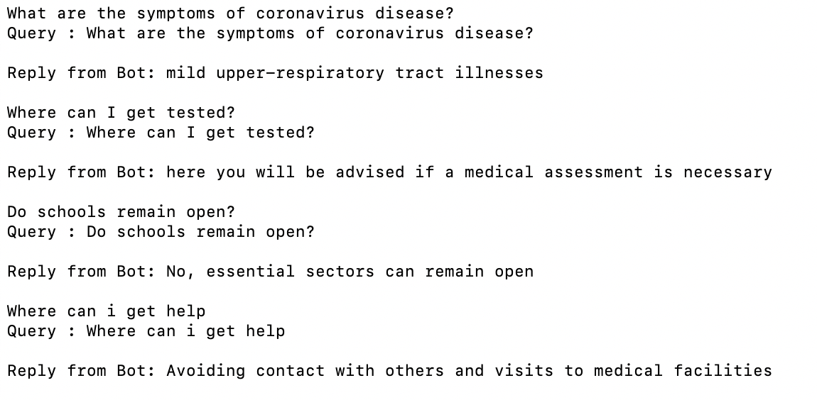

# Version 2: Build a Dialogflow based FAQ bot

In order to build dialog flow we used knowledge based corpus, custom intents, custom action and parameters and Realtime webhook to do backend call.

## **Knowledge based corpus**

Question and Answer columns from extracted & processed dataset was used. This was fed to dialog flow. Screenshots below

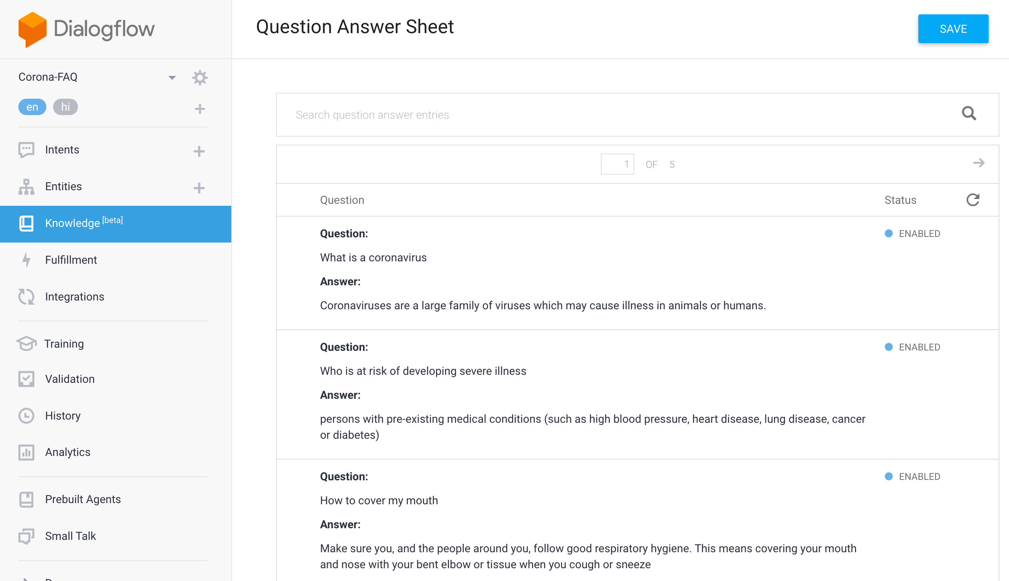

## **Intent Action and Parameters**

Specific Intents and actions were defined to streamline the user query and return appropriate answers, as shown in screenshot below.

As shown in screenshot below, different users might use Corona, Covid, Covid-19 interchangeably and chatbot should be able to interpret them in similar fashion

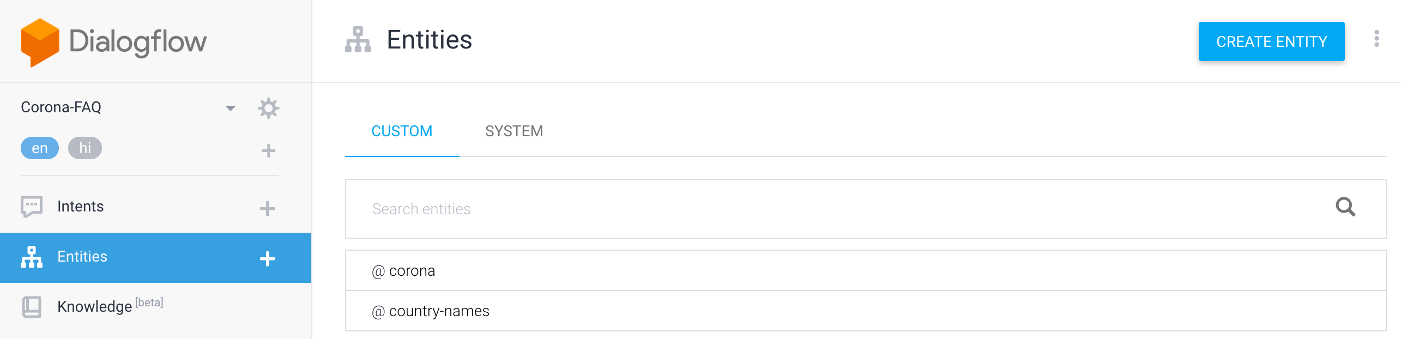

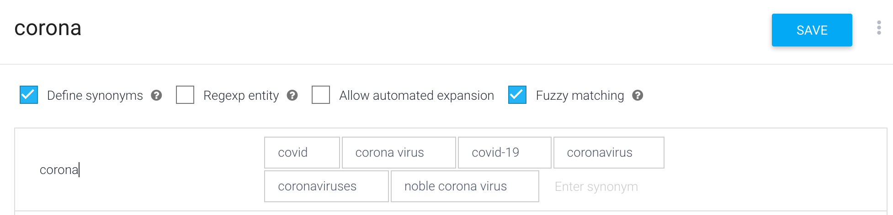

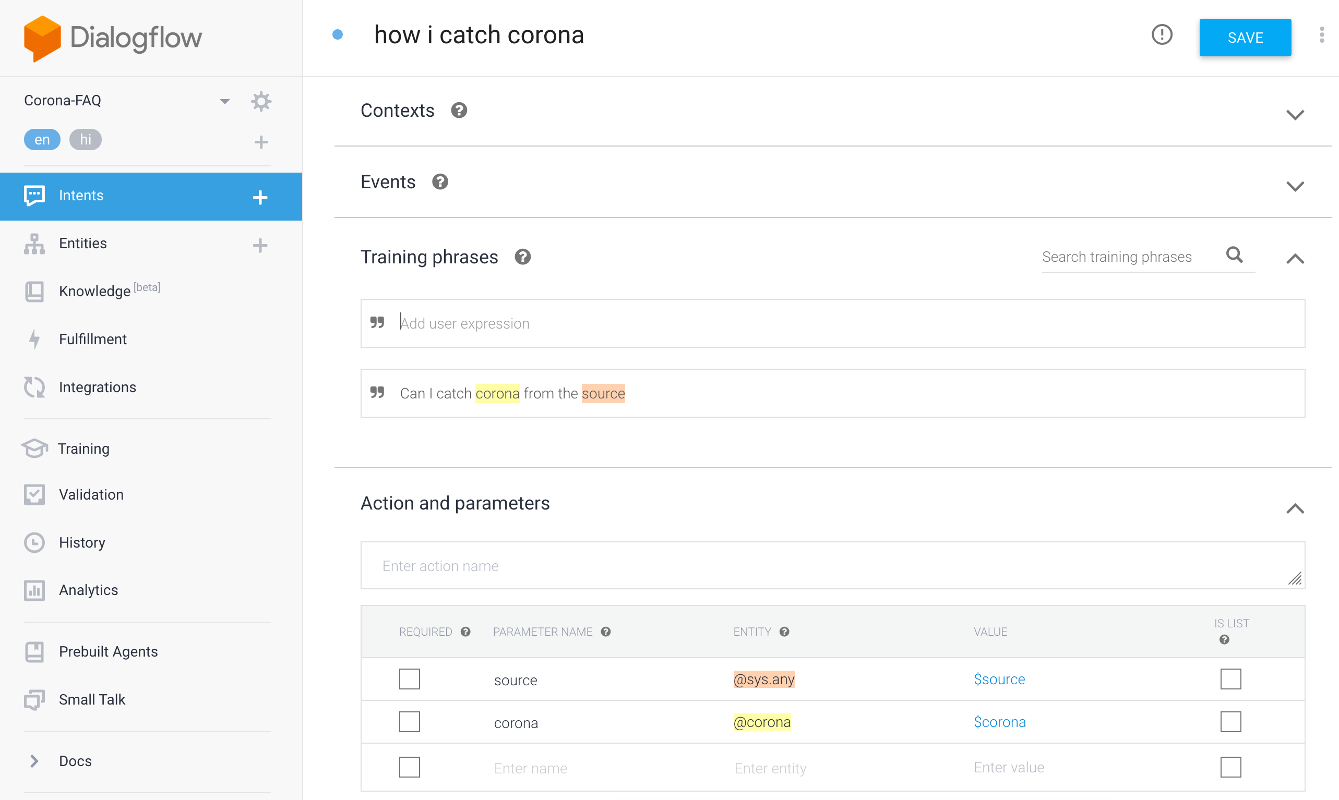

## **Realtime webhook**

Webhook based system was connected to locally deployed flask model which would server queries

directly from backend in Realtime. This can provide realtime updated information from backend, instead of just relying on knowledge base. Screenshot below with details.

Steps to enable webhook

1. Run a flask server in localhost
2. Use ngrok to connect localhost to publicly available IP
3. Enable webhook for relevant Intents.
4. Enable webhook in fulfilment in Dialogflow

**Flask server running on localhost**

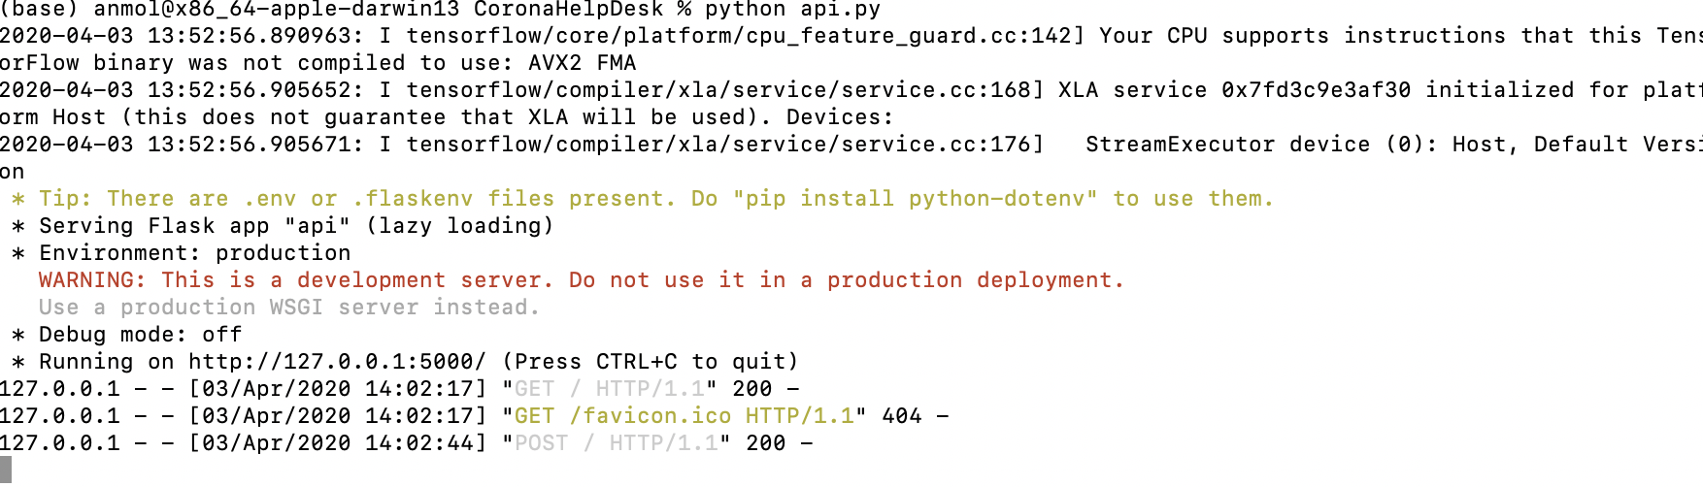

**Ngrok connecting Dialogflow Webhook**

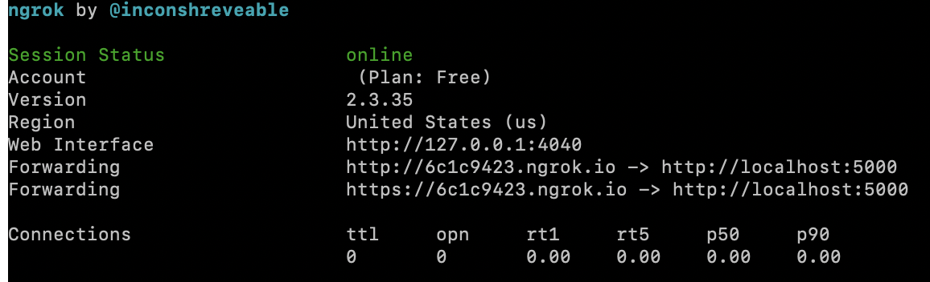

**Enable webhook fulfilment in Query**

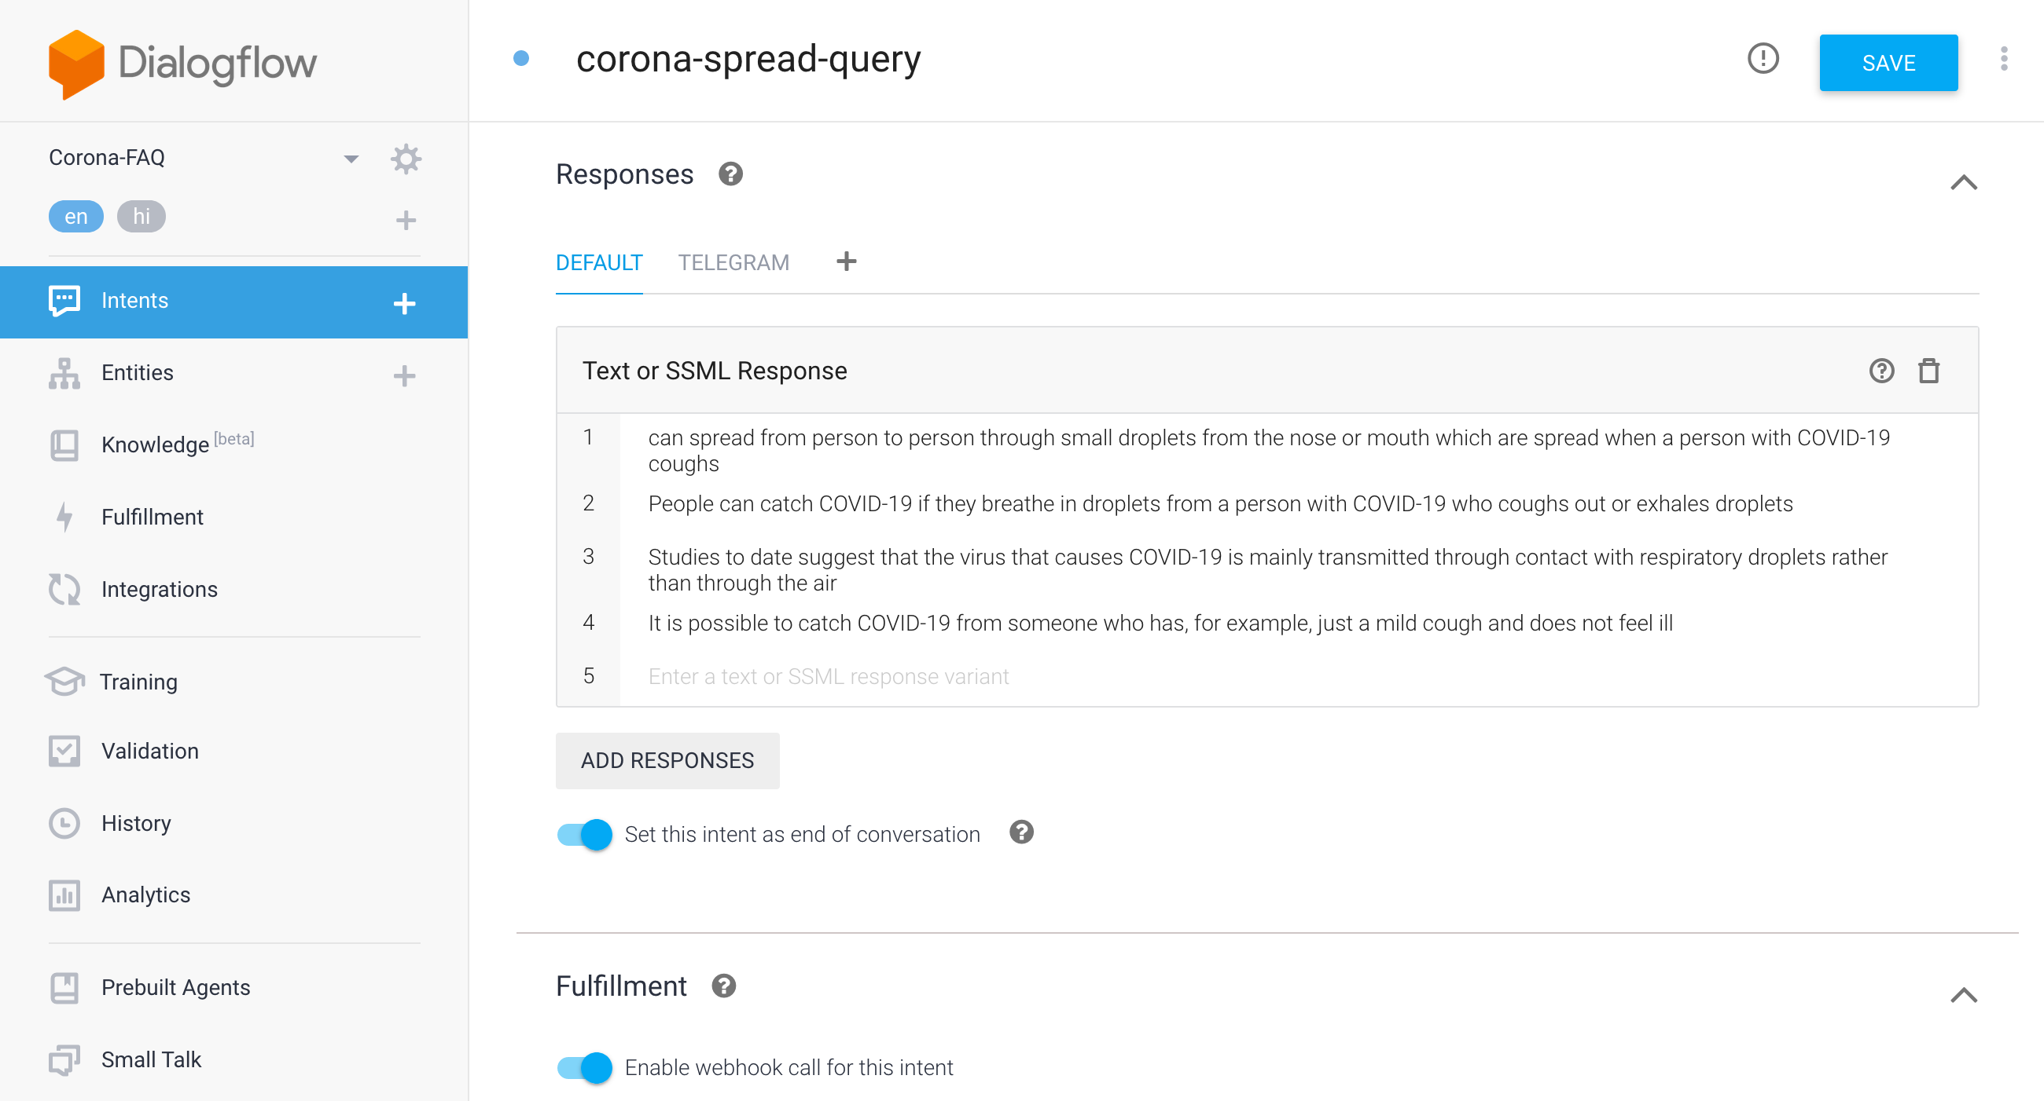

**Fulfilment through Webhook**

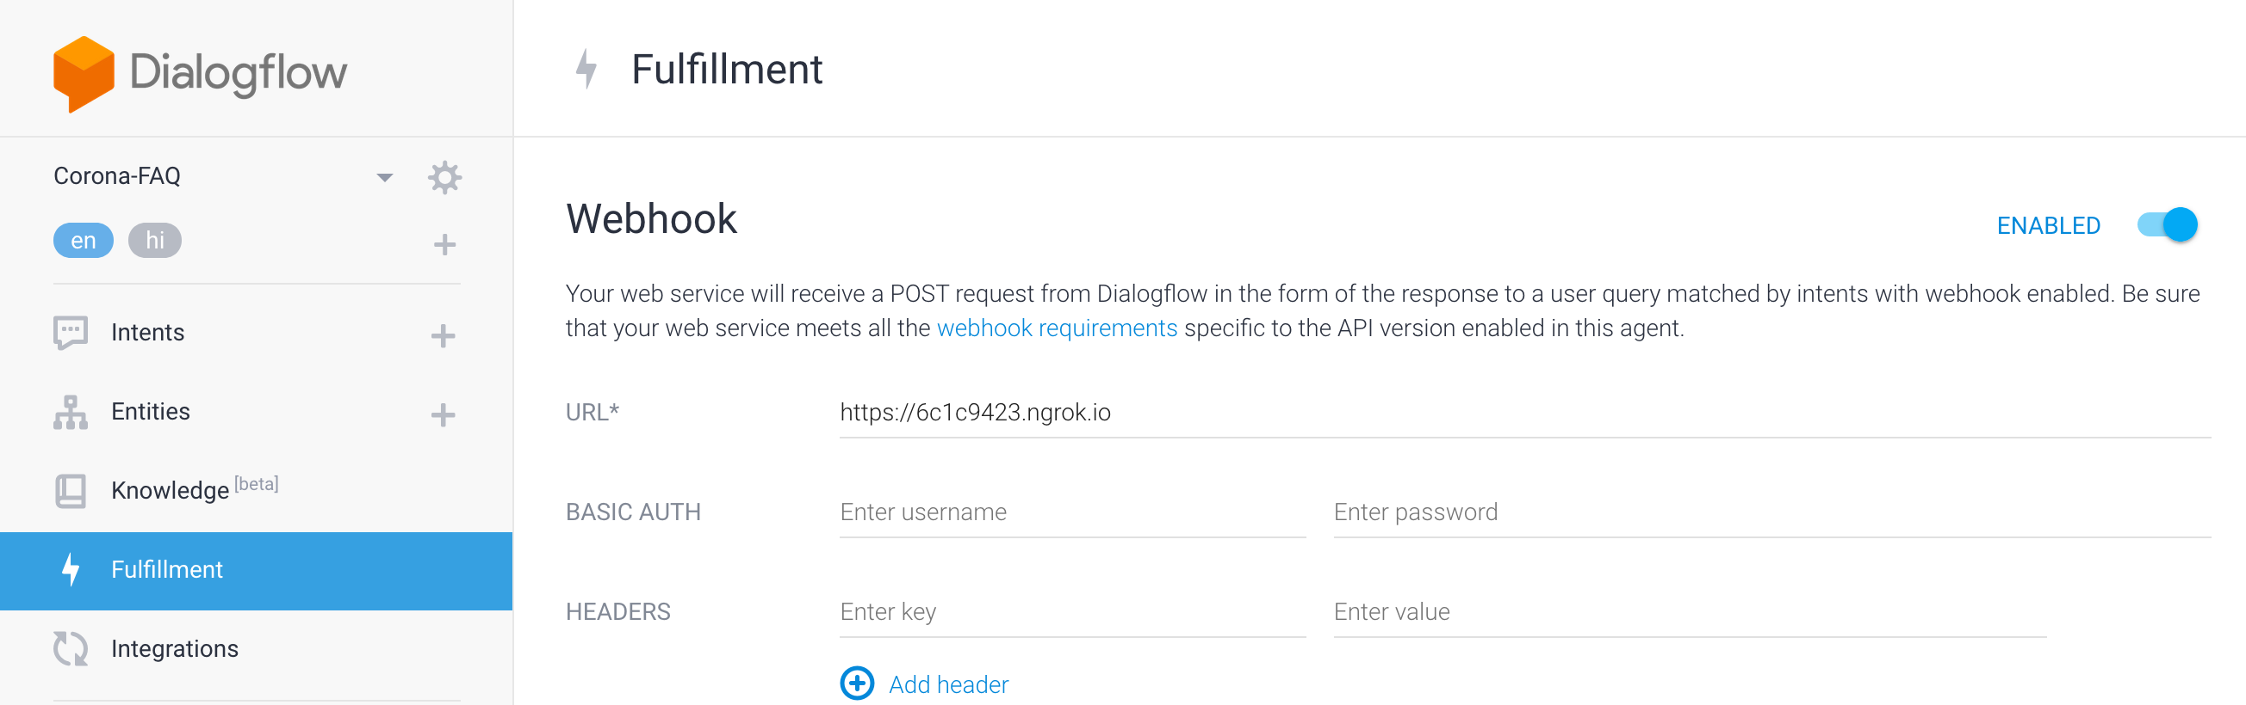

## Web Based Bot

**Chatbot URL -** [**https://bot.dialogflow.com/7ece3edf-bff2-4527-ae49-c68209b471ee**](https://bot.dialogflow.com/7ece3edf-bff2-4527-ae49-c68209b471ee)

Web based bot is using the knowledge based corpus and intents created explicitly. Screenshot from one such Intent below

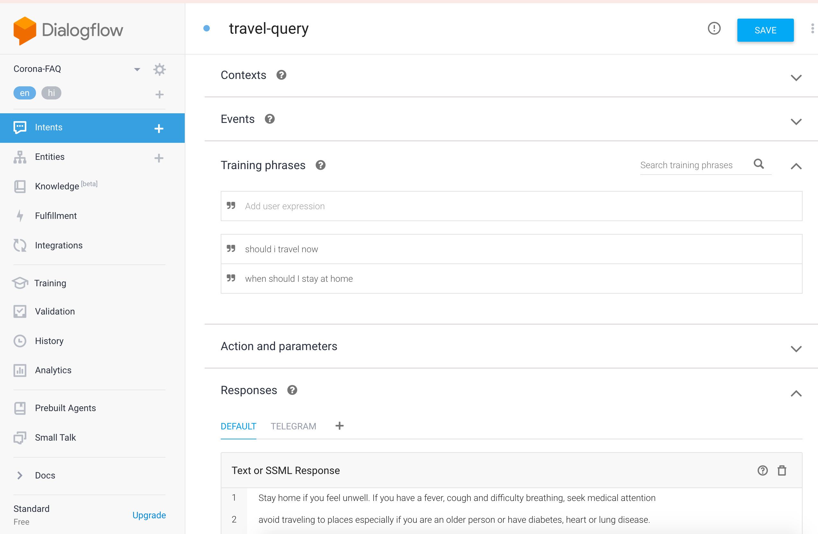

**Screenshot : Web based demo dialogflow**

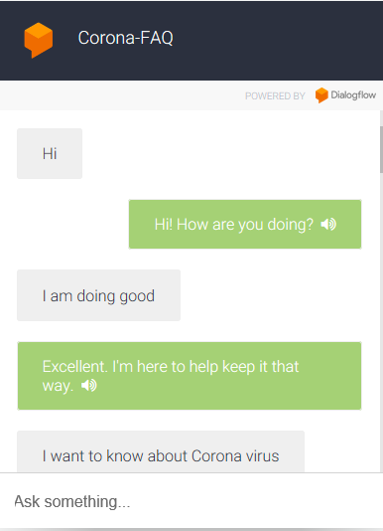 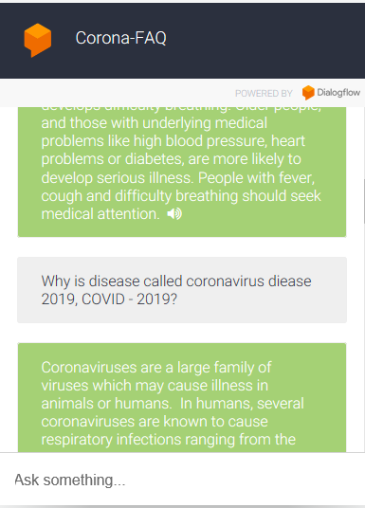

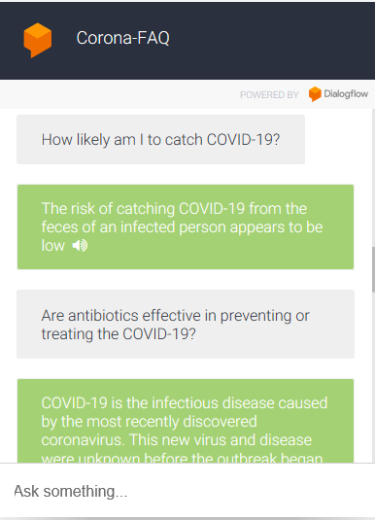 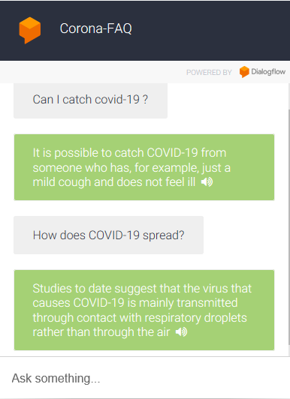

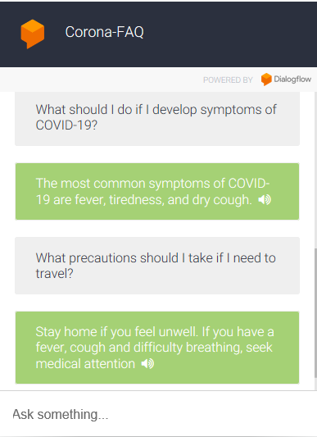 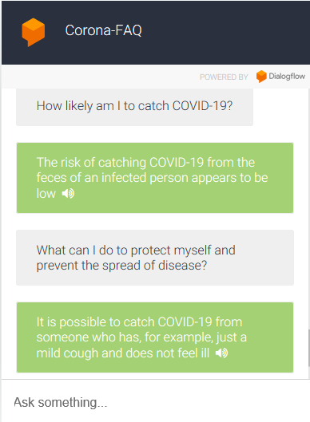

## Telegram Bot

We created a telegram bot app and connected it to our dialogflow. It is accessible at @AAIAssignmentCorona_Bot.

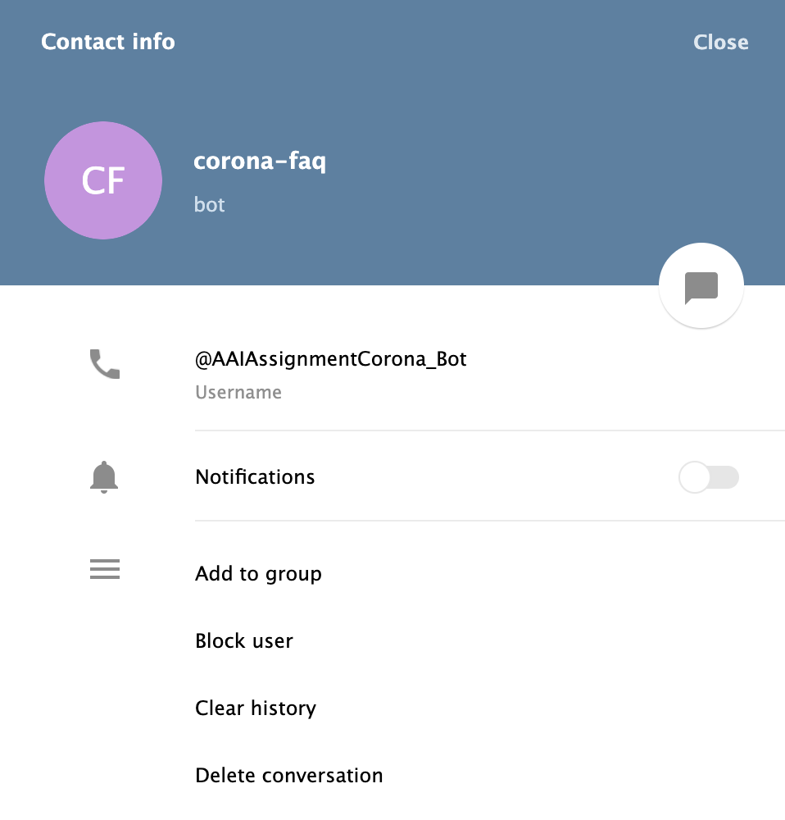

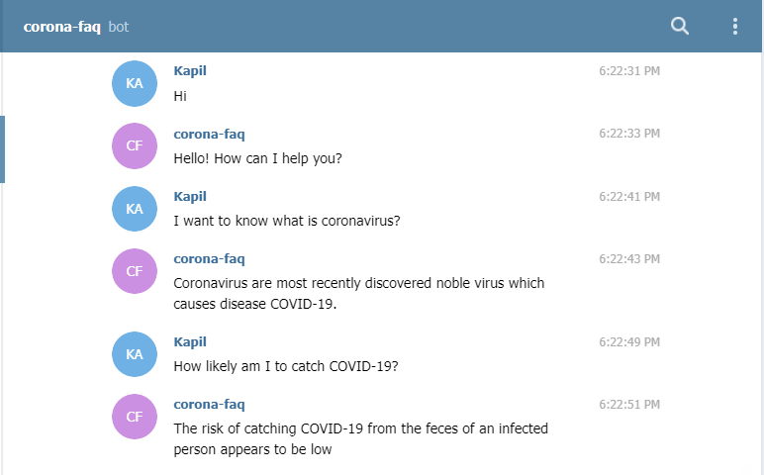 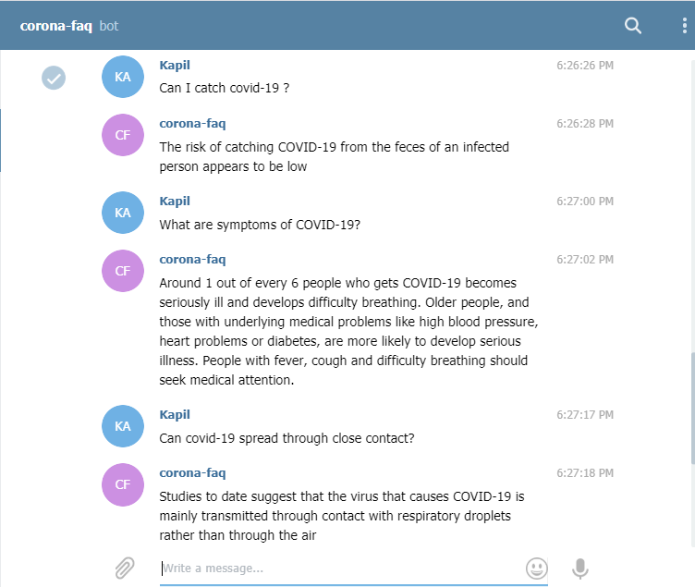

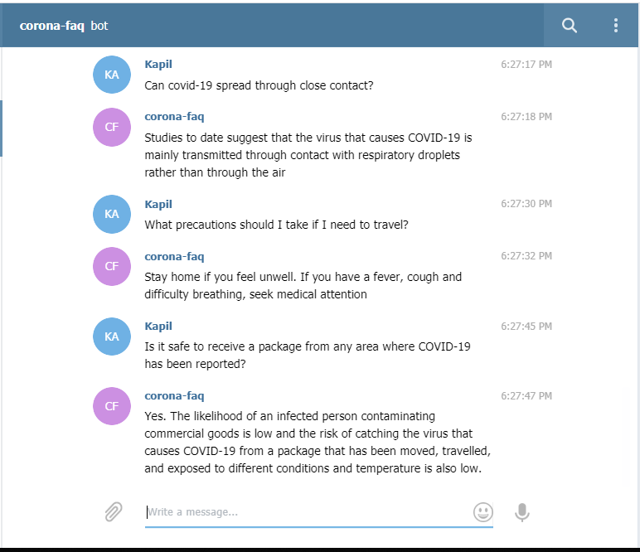

# Discussion and Ways to Improve

## Personas

We could see the following personas using our information bot.

* ***Potential corona patients:*** These are the users who currently have some symptoms and are wondering if theirs match what corona has. Their sentiment could be nervous or concerned and they would like to know what are the complete set of symptoms that uniquely match corona. It is absolutely critical to give them the accurate and reliable information. While symptoms is their primary information sought, details like who to call, when to visit the doctor, tests required and self-isolation approaches would be highly relevant secondary information.
* ***Concerned Parents:*** Parents are concerned about the kids and they are eager to know how Corona spreads and how to avoid such circumstances. Their sentiment would be curious and proactively concerned. Their primary information sought is spread patterns, hotspots, foods and medications that could compound. Their secondary information sought would be corona symptoms, demographics of people who are impacted the most, how long corona survives on any surface and any precautions on meds and foods to be taken.
* ***Curious Kids:*** These are curious because they have their virtual classroom assignments that are driving them to do research and come back with some statistics and solutions. Their sentiment will be curious to learn. Their primary information sought would be the statistics like how many countries are impacted, how many impacted in their state/country, the duration of incubation, how to stay safe. Their secondary information sought would be the travel moratorium details.

## Ideal Conversation Flowchart

An ideal flow chart has been shown below, which greets the user and answers relevant queries

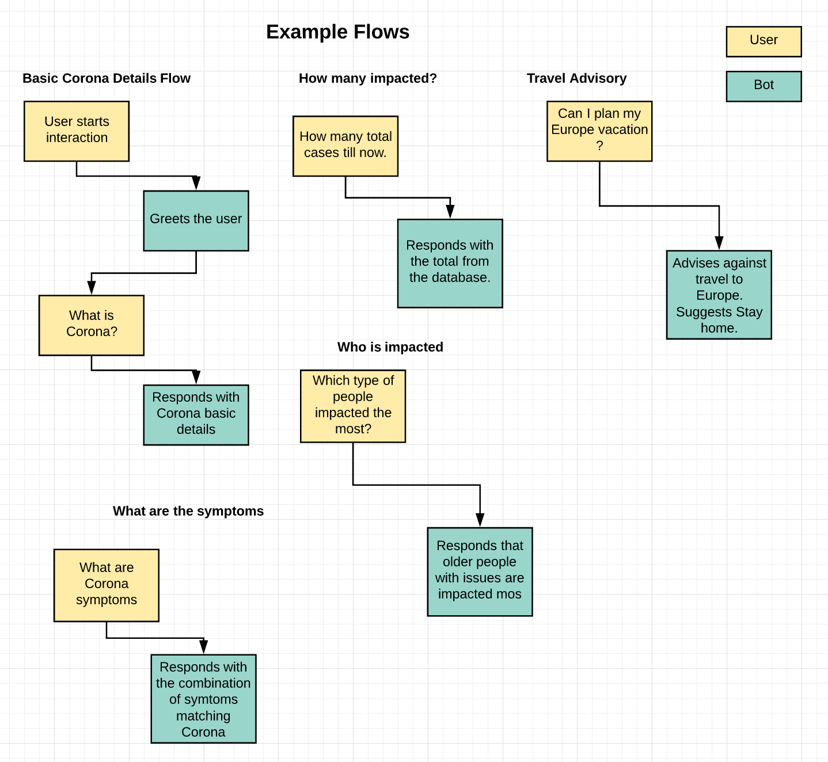 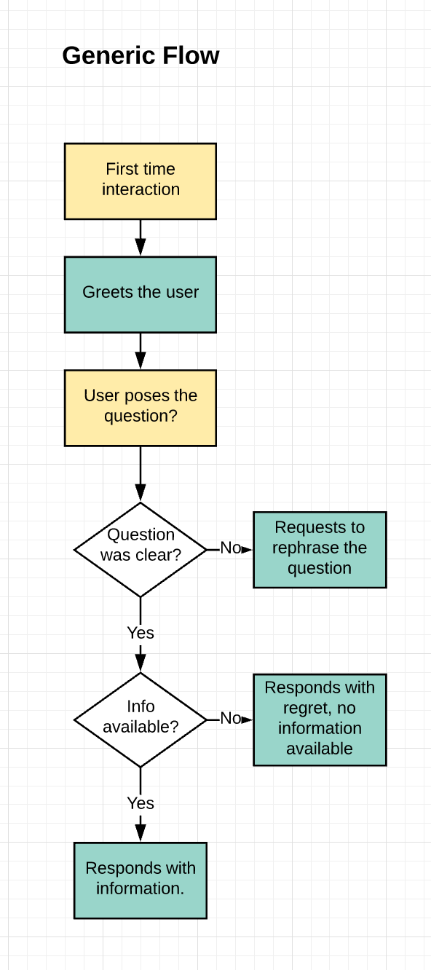

## Ways to improve your bot

### Improve user experience

* Create intuitive UI using jquery and other web development tools.
* Add follow-up intents to keep the conversation open, and answer a follow up query – Right now every query is considered independently
* Add different integrations with WhatsApp, Facebook Messenger or even a play store app.

### Improve bot knowledge base

* Increase knowledge base to connect to Realtime data on counts, affected people, government efforts etc

## Multiple model deployment

* We have focussed on similarity based models like Question similarity or bi directional similarity models like BERT, but we can try other models like RNN based deep learning models
* Also, tf-idf and similarity based simpler model could have been improved further.

### Realtime Integration

* Cloud Deployable Model – Flask server can be deployed on cloud, so it can server 24x7, instead of local deployment

# References

* <https://medium.com/analytics-vidhya/adapting-bert-question-answering-for-the-medical-domain-2085ada8ceb1>
* <https://medium.com/@aainabajaj39/domain-specific-excel-dataset-to-squadv1-1-dataset-format-using-python-2b99f827b8a2>
* <https://towardsdatascience.com/lets-build-an-intelligent-chatbot-7ea7f215ada6>
* <https://medium.com/datadriveninvestor/build-your-first-chatbot-in-10-lines-of-code-88c4f15e39c9>
* <https://towardsdatascience.com/nlp-building-a-question-answering-model-ed0529a68c54>
* <https://towardsdatascience.com/modern-question-answering-systems-explained-4d0913744097>
* <https://towardsdatascience.com/identifying-duplicate-questions-on-quora-top-12-on-kaggle-4c1cf93f1c30>